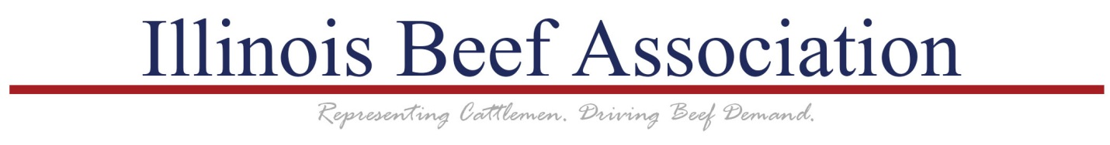

Sponsorship Requests:

The Illinois Beef Association Board of Governors is charged with directing programs that deliver on IBA’s 2-pronged mission: To serve our members and promote the economic viability of the beef industry in Illinois; and, to build demand for beef through education, communication, and marketing.

Strategically, our annual budget addresses a number of program areas funded either or both by the Policy and Checkoff Divisions of our organization meant to accomplish both of those missions. These program areas include Membership Recruitment & Services, Producer & Youth Education, Production Research, Issues & Reputation Management, Legislative & Advocacy, Promotion & Marketing, and Producer Communications & Events.

Most of IBA’s funds are planned and budgeted months in advance by the Board of Governors. Some of these funds are further administered by a standing committee such as the IBA PAC Club or the Checkoff Research Committee. IBA does sponsor a number of activities and events each year within its set spending plans. If you or your organization is interested in receiving a sponsorship from the Illinois Beef Association, please consider the following.

The most attractive proposals are those that directly address IBA’s 2-pronged mission statement and seek to perform a function which IBA is not currently performing or is unable to perform.

Priority target audiences of programs funded by the IBA Checkoff Division are Millennial thought leaders, nutrition influencers, and decision makers within the retail and foodservice industries.

If you would like to submit a funding proposal for consideration by IBA, please complete the following form and send to Reid Blossom at the IBA office. Information needed for IBA to consider your proposal includes a summary of you and/or your organization, a description of the effort you’re leading, and an estimate of the total budget of your project. As well, please include relevant ties from your project to IBA’s program areas, the IBA Strategic Plan, and/or the Beef Industry Long Range Plan.

Note that the Illinois Beef Association’s fiscal year starts October 1st each year and any significant partnership funding must be requested and approved prior to that date for inclusion in the regular IBA annual budget.

Thank you for your interest in the Illinois Beef Association.

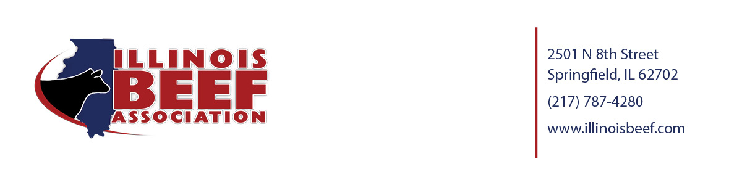

Illinois Beef Association Sponsorship Inquiry Form

Summary of Organization Requesting Sponsorship
Project Description
Total Budget and IBA Share
Relevance to Beef Industry

Date Form Submitted to IBA:__________________

